**Assignment 1:**

**Class Diagram**

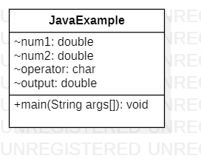

**Sequence Diagram**

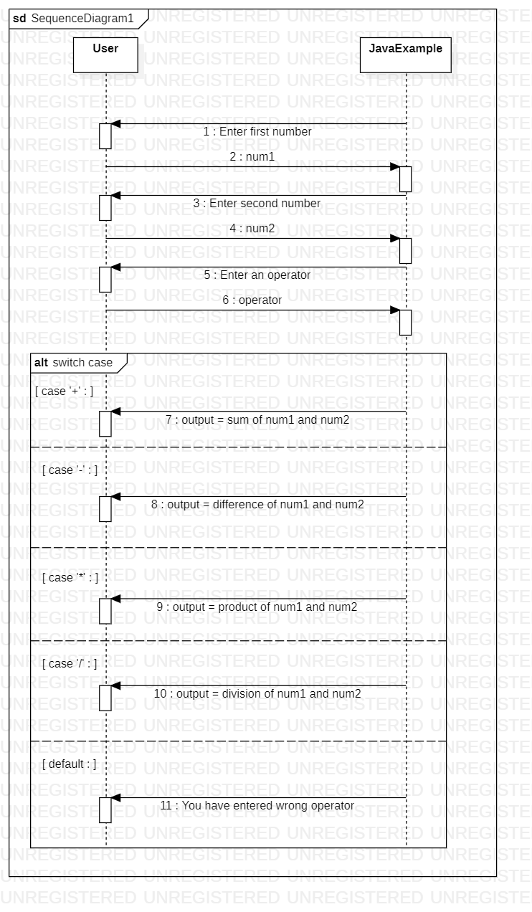

**Assignment 2:**

**Class Diagram**

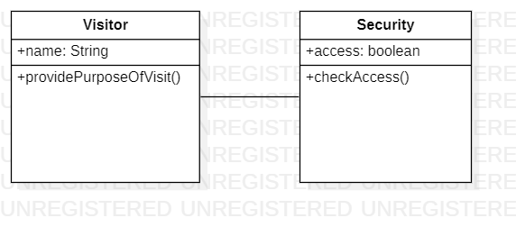

**Sequence Diagram**

